CDMS DR Drill - 2025

DOCUMENT CONTROL
DOCUMENT NAME | CDMS DR Drill - 2025
ABSTRACT | CDMS DR Drill - 2025
DOCUMENT REFERENCE | CDMS DR Drill - 2025

AUTHORISATION

Document Owner | Reviewed By | Authorized By
Harmohan Singh | Himanshu Sharma | Pardeep Singh

VERSION HISTORY
VERSION | DATE | PREPARED BY | CHANGES & REASONS FOR CHANGE
1.0 | 30-June-2025 | Harmohan Singh | First Version

DOCUMENT DETAILS
Policy Reference No. / Process Reference No. | CDMS DR Drill - 2025
Policy Reference Name / Process Reference  Name | CDMS DR Drill - 2025
Release Date | 30-June-2025
Next Review Date | 30-June-2025

Table of Contents
DOCUMENT CONTROL 2
AUTHORISATION 2
VERSION HISTORY 2
DOCUMENT DETAILS 2
1. Introduction & Purpose 4
2. Scope 4
3. Objectives 4
4. Roles and Responsibilities 4
5. DR Drill Scenario 5
6. DR Activation Sequence (Failover) 5
7. Results and Validation 6
8. Lessons Learned 6
9. Appendices 7

Introduction & Purpose
The Disaster Recovery (DR) Drill for the CDMS application was conducted on 27th June. The objective was to validate the effectiveness of the DR Plan, ensure readiness of the DR site, and confirm that the Recovery Time Objective (RTO) and Recovery Point Objective (RPO) are achievable. The drill simulated a complete outage of the primary site and involved a full failover to the DR site in South India. All critical steps were executed successfully, and the application was restored within the defined RTO.

Scope
This drill covered:
- CDMS Application VM and associated infrastructure.
- Azure SQL Database with geo-replication.
- DNS updates and network security configurations.
- Teams involved: Crisis Management Team (CMT), DR Coordinator, Cloud Team, Security Team, Application & Database Admins.
- DR site: South India Azure region.

Objectives
The primary objectives of this DR Drill are:
- Validate the DR Plan procedures and team readiness.
- Ensure minimal service interruption and data loss.
- Achieve RTO of 60 minutes and RPO of 60 minutes.
- Confirm the failover and failback mechanisms.
- Test communication protocols and stakeholder updates.

Roles and Responsibilities

# | Role | Responsibility | Primary Contact
1 | Crisis Management Team (CMT) | Overall oversight, communication, and Disaster Declaration Authority. | Pardeep Singh
2 | DR Coordinator | Manages the execution of the DR plan, coordinates technical teams | Harmohan SIngh
3 | Security Team | Manages DNS updates, firewall rules. | Surendra Vishwakarma
4 | Cloud Team | Manages Azure VMs, load balancers, and operating systems at both primary and DR sites | Dabreo Blanche
5 | Application & Database Admin (Apps DBA) | Manages the CDMS Application, Azure SQL Databases, and Application configuration. | Pardeep Nehra.

DR Drill Scenario
The drill simulated a complete outage of the primary site due to a hypothetical infrastructure failure. The scenario assumed no estimated time of resolution within the RTO, prompting the CMT to declare a disaster and initiate the DR Plan.

DR Activation Sequence (Failover)

S. No. | Description | Ownership | Status | Actual-Start-Time | Actual-End-Time | Duration
DR Failover
1 | Stop Production Services (App VM). | Blanche | Done | 8:05PM | 8:09PM | 4 min
2 | Failover to the DR PaaS DB and make it primary. | Blanche | Done | 8:09PM | 8:12PM | 3 min
3 | Failover to the DR App VM and make it primary. | Blanche | Done | 08:16PM | 08:21PM | 5 min
4 | Update swarajcdms.com DNS to point to 74.224.99.82. | Surendra | Done | 08:21PM | 08:23PM | 2 min
5 | Update DB Connection String in the application | Pardeep Nehra | Done | 08:23PM | 08:32PM | 9 min
6 | Add DR App VM to LB Backend | Blanche | Done | 08:25PM | 08:28PM | 3 min
7 | Add the DR App VM to the NSG, and add rules | Blanche | Done | 08:30PM | 08:32PM | 2 min
8 | Start Production Services (DR VM) | Pardeep Nehra | Done | 08:32PM | 08:35PM | 3 min
9 | Application & Business use-case testing. | Pardeep Nehra | Done | 08:35PM | 09:25PM | 50 min
DR Failback
10 | Commit & re-protect App VM | Blanche | Done | 08:35PM | 01:00PM | 4 hours 25 min
11 | Stop Production Services (DR VM). | Pardeep Nehra | Done | 1:12AM | 1:15AM | 3 min
12 | Failback to Prod PaaS DB. | Blanche | Done | 1:15AM | 1:16AM | 1 min
13 | Failback to Prod App VM. | Blanche | Done | 1:16AM | 1:22AM | 7 min
14 | Update DB Connection String in the application | Pardeep Nehra | Done | 1:24AM | 1:30AM | 6 min
15 | Add DR App VM to LB Backend | Blanche | Done | 1:24AM | 1:27AM | 3 min
16 | Update swarajcdms.com DNS to point to 52.172.208.40. | Surendra | Done | 1:27AM | 1:28AM | 1 min
17 | Start Production Services (App VM) | Pardeep Nehra | Done | 1:28AM | 1:30AM | 2 min
18 | Application & Business use-case testing. | Pardeep Nehra | Done | 1:30AM | 1:45AM | 15 min
19 | Commit & re-protect App VM | Blanche | Done | 1:37AM | 1:45AM | 7 min

Results and Validation
- All failover steps completed successfully.
- Application was accessible from the DR site.
- Smoke tests and critical functionality checks passed.
- No data loss observed.
- DNS propagation was completed within acceptable time.

Lessons Learned
- Positives: Quick coordination, successful failover, minimal downtime.
- Challenges: Replication time for Failback to primary region took more than 5 hours, which was not anticipated.
- Recommendations: Plan the DR Drill activity window, considering the time taken for the replication to complete for the failback to Primary Production Azure Region.

Appendices
Screenshots –
Stop Application Services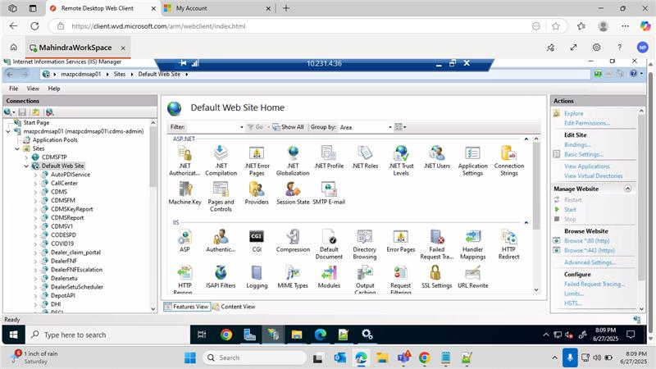

Failover CDMS Database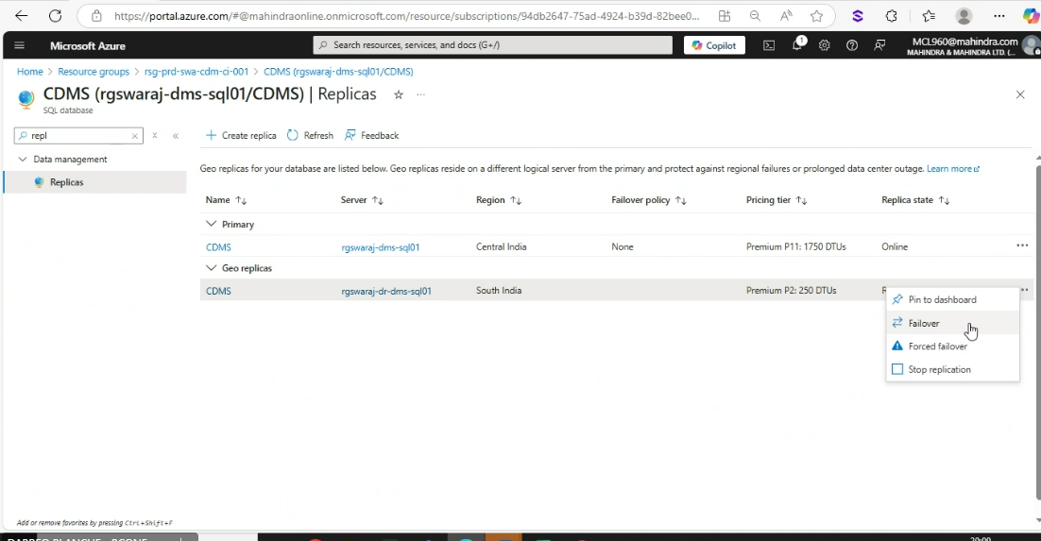
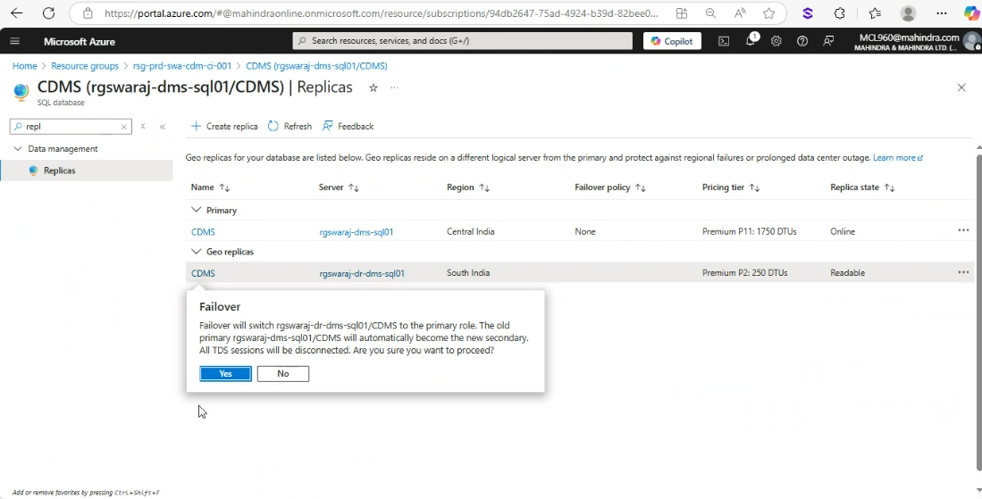

Failover CDMS Application VM
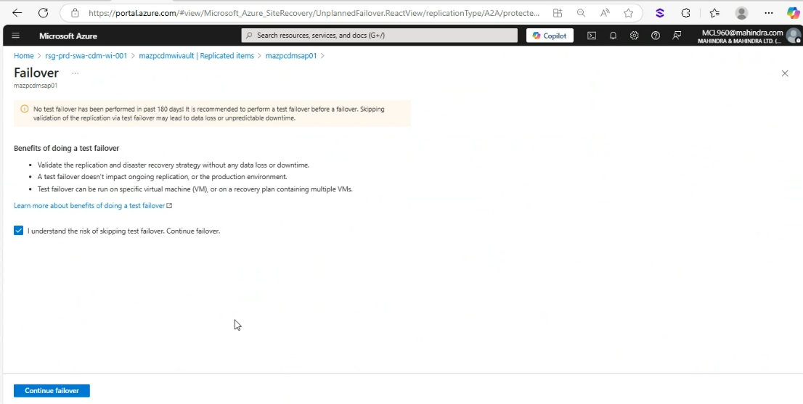
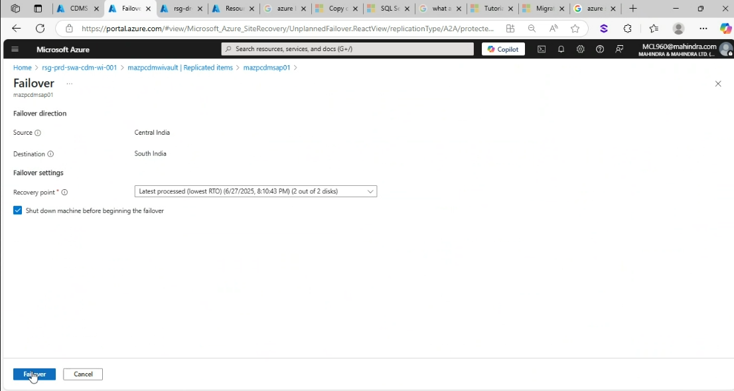

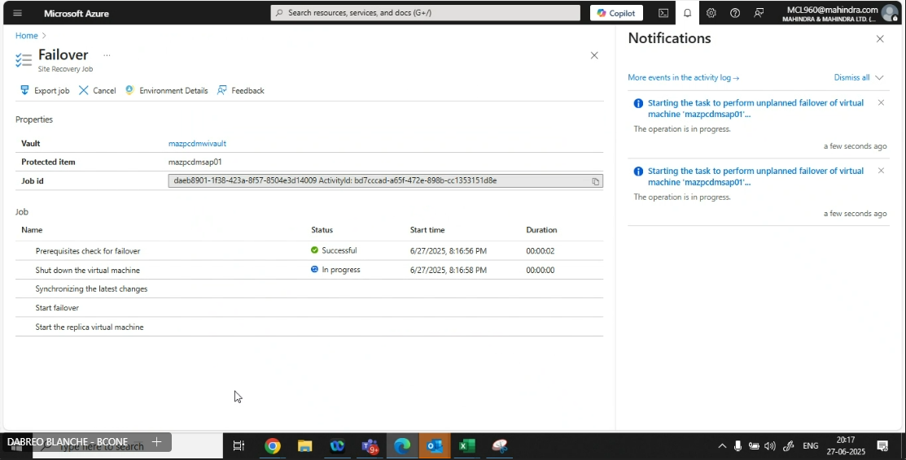
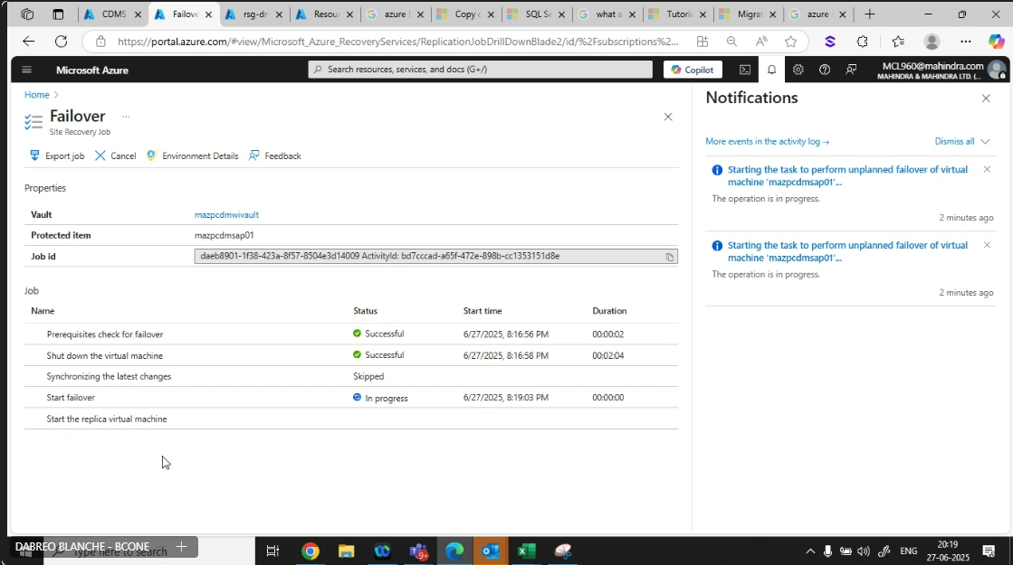

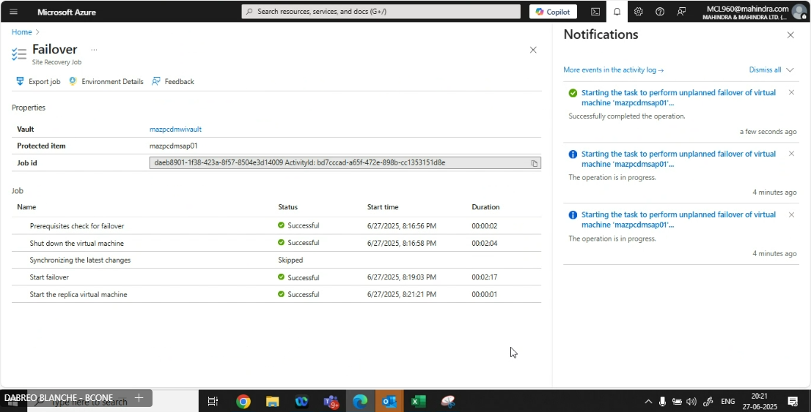

DNS Update
Existing –
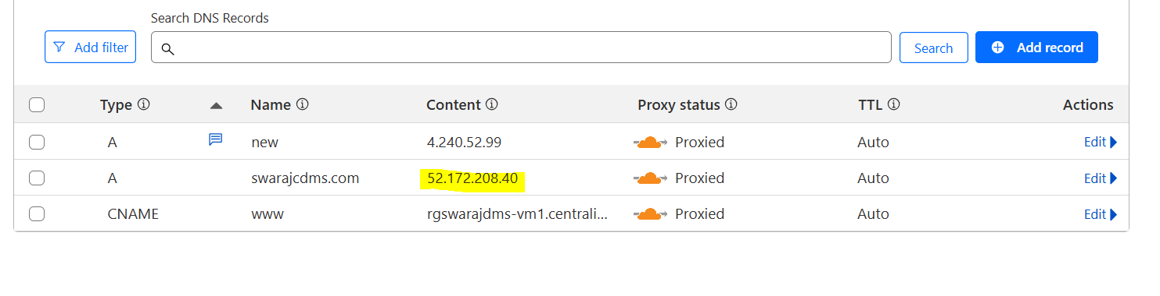
New –
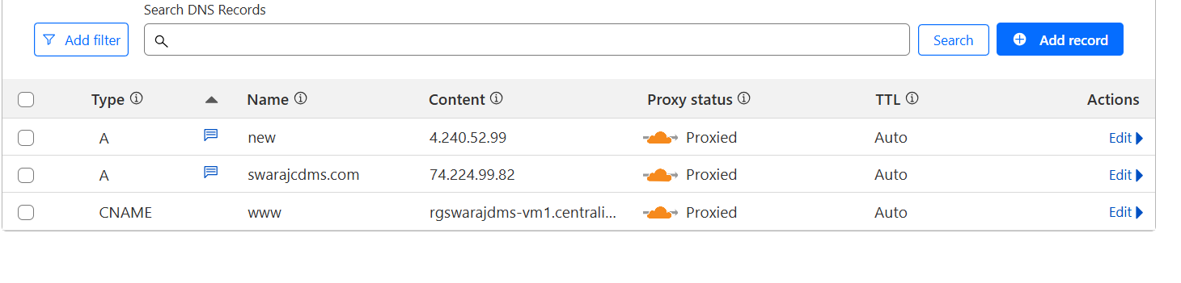
Added VM to LB Backend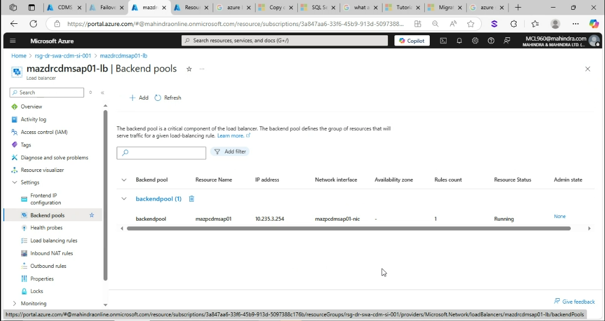

Added VM to NSG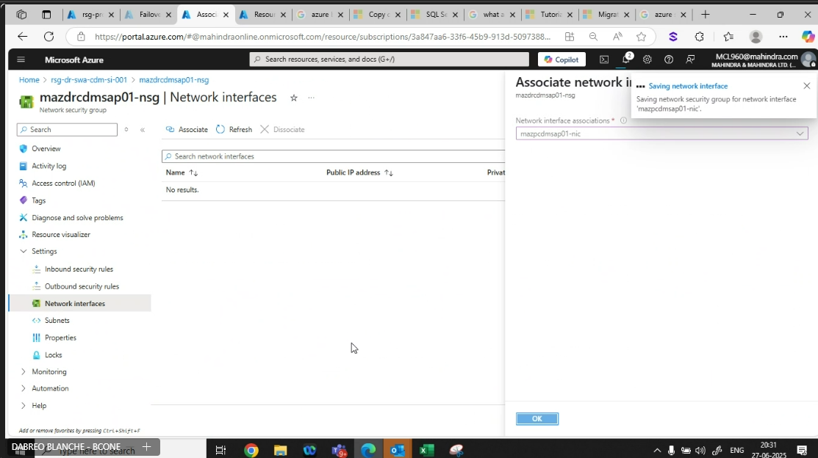

Commit Replication –
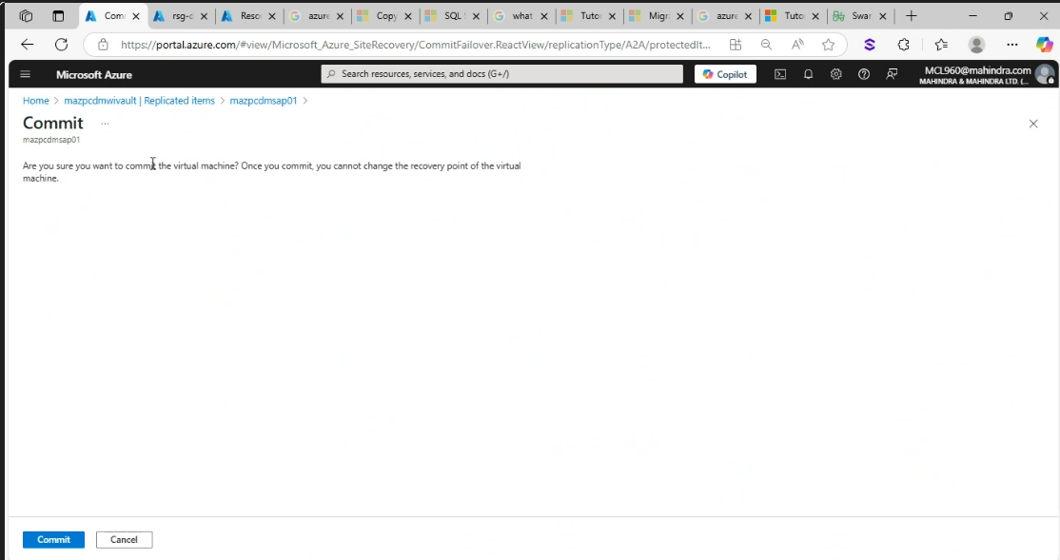
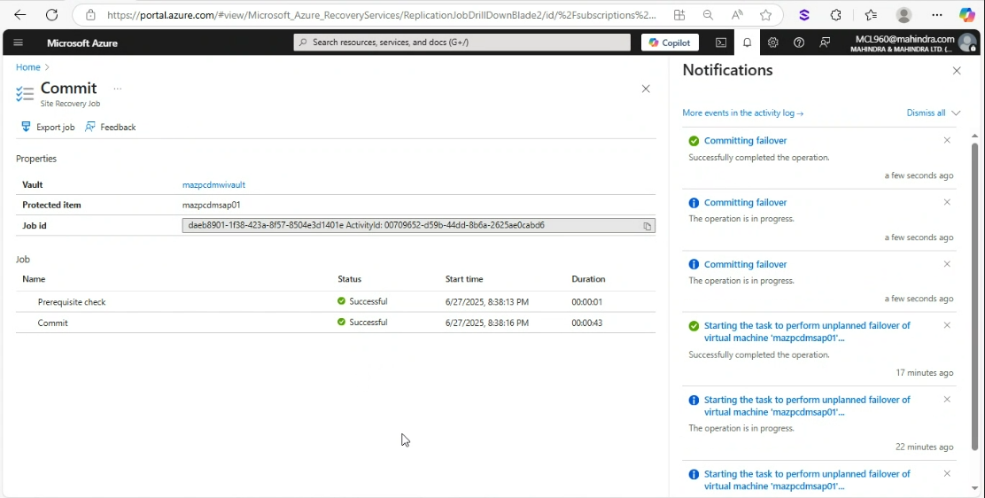

Re-protect DR App VM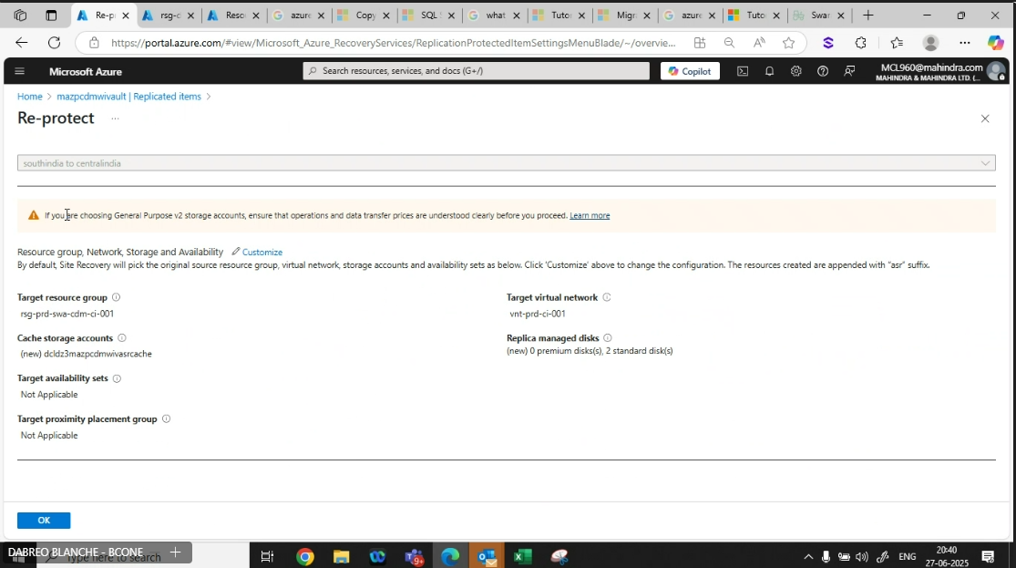
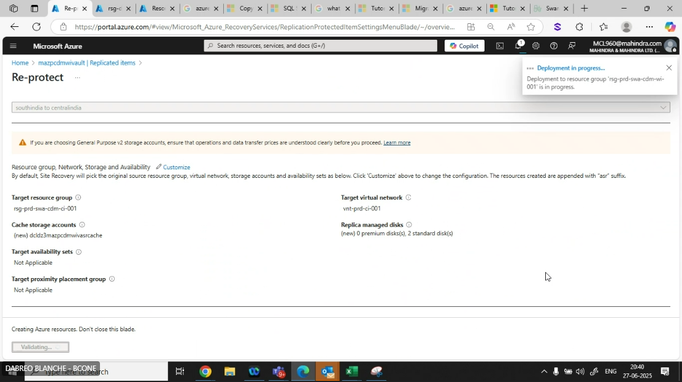

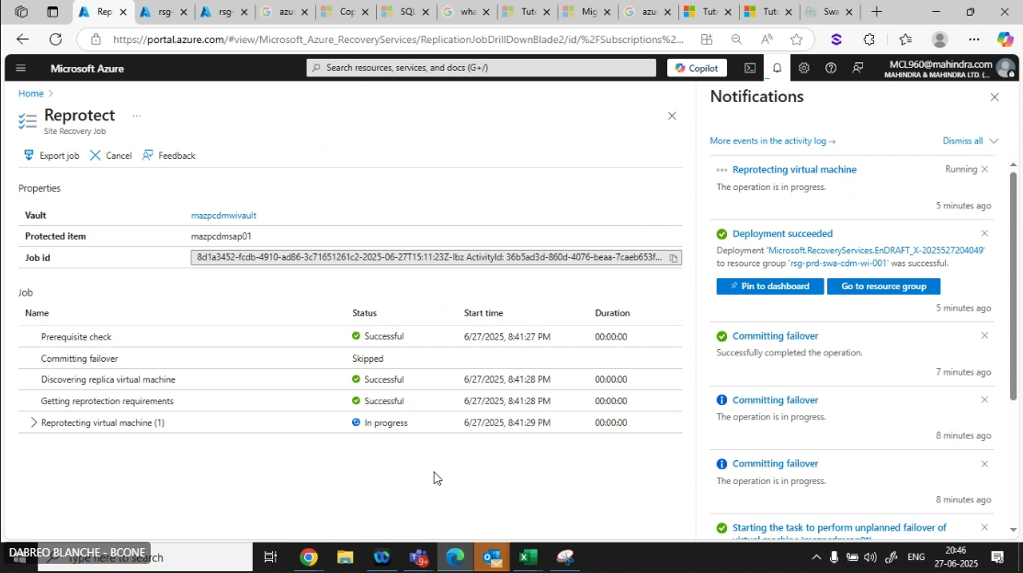
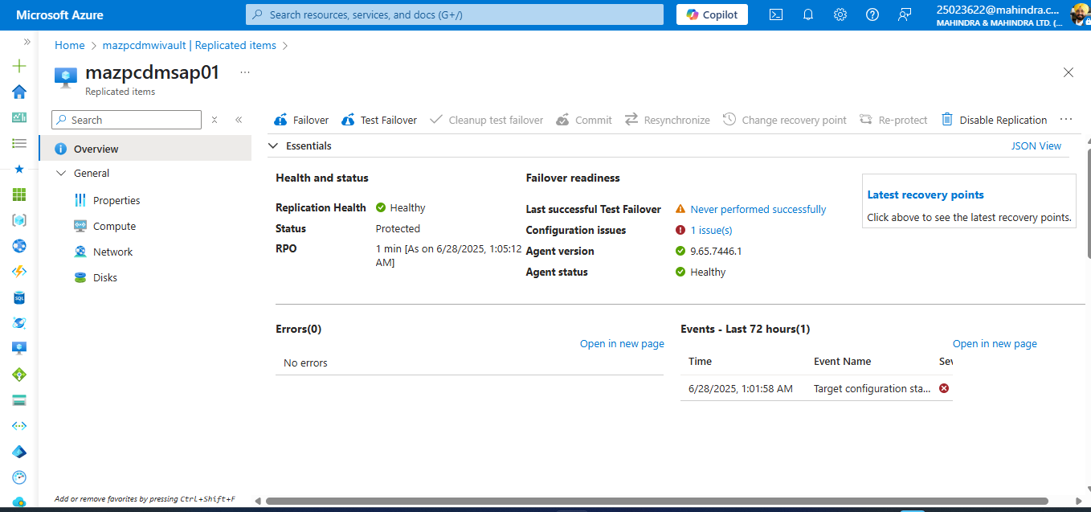

Application Test Cases –
CDMS Dashboard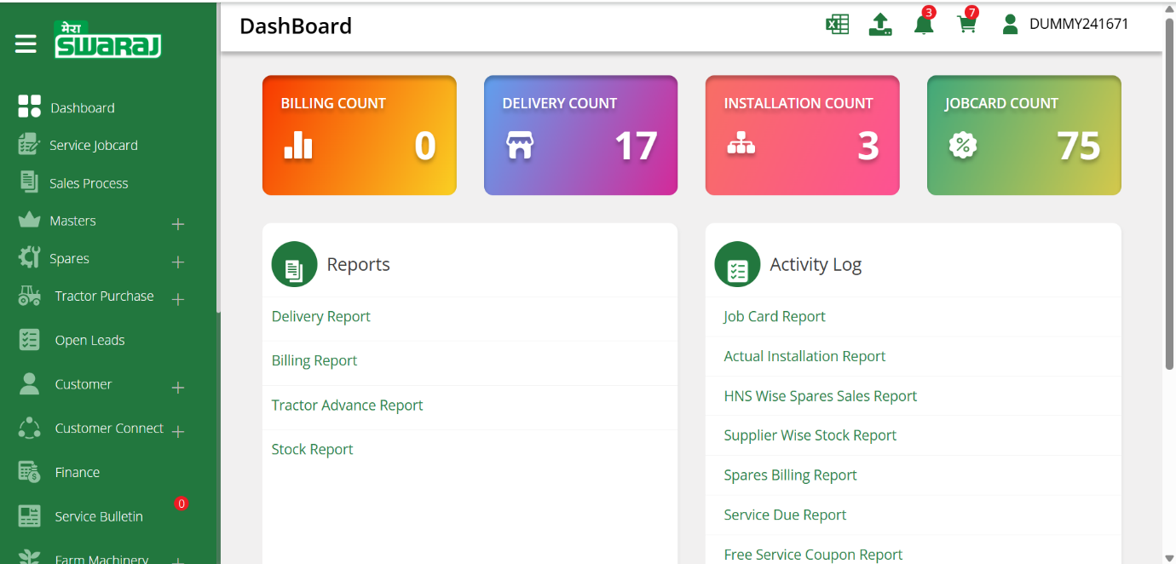
Mobile Application Log from meraswaraj app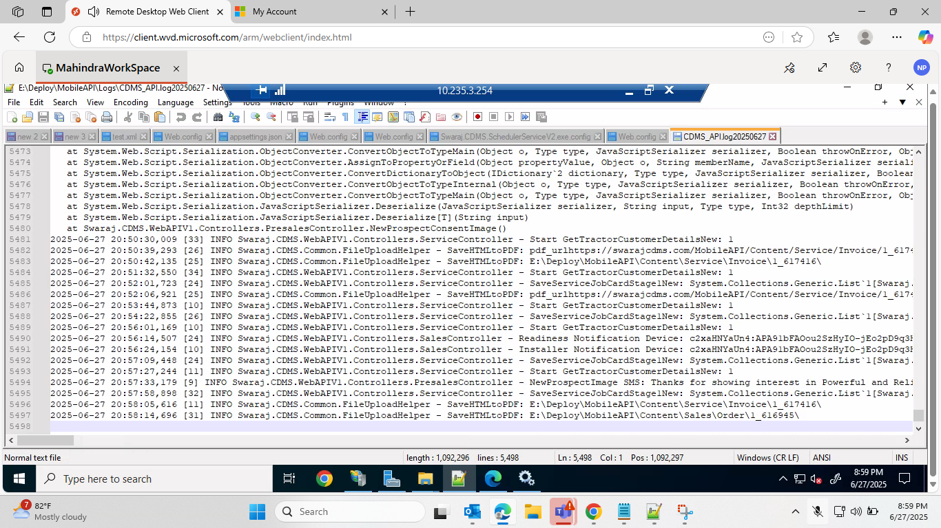
SAP Data reception evidence
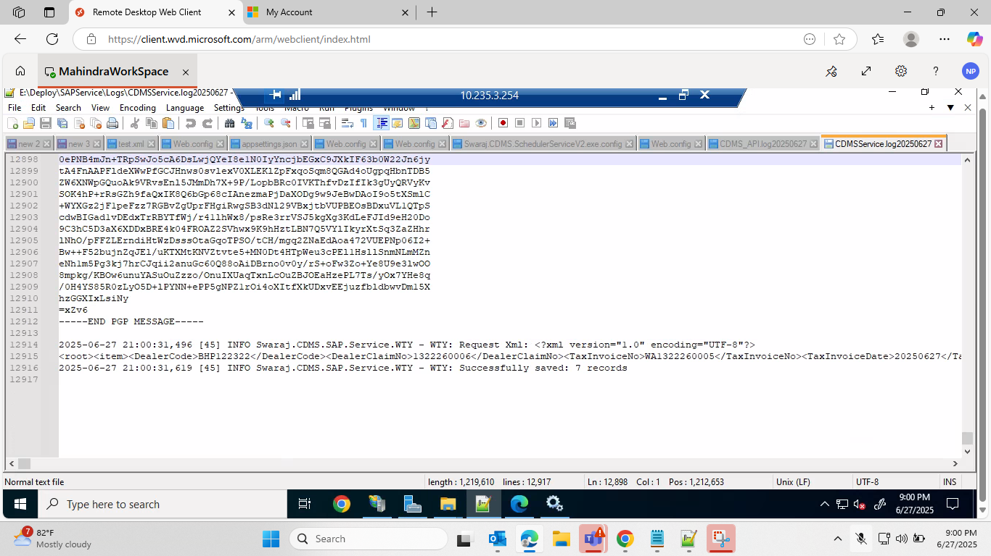
Data Egress to SAP Evidence
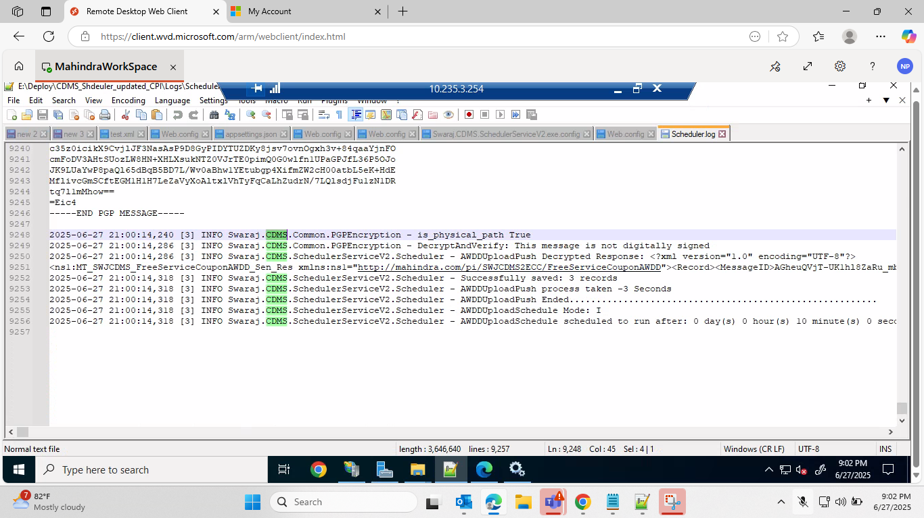
MeraSwaraj Mobile App Validation
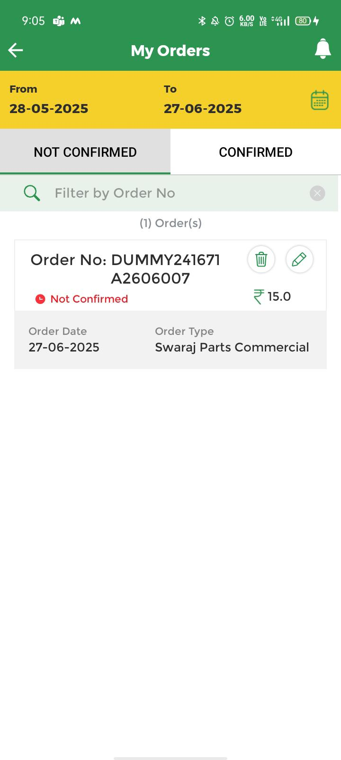
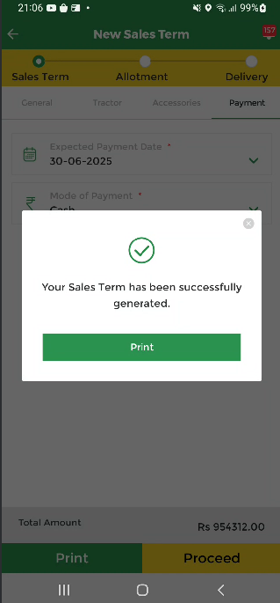
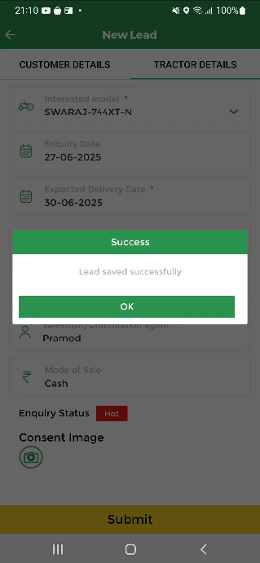

Failback to Primary Azure Region – Central India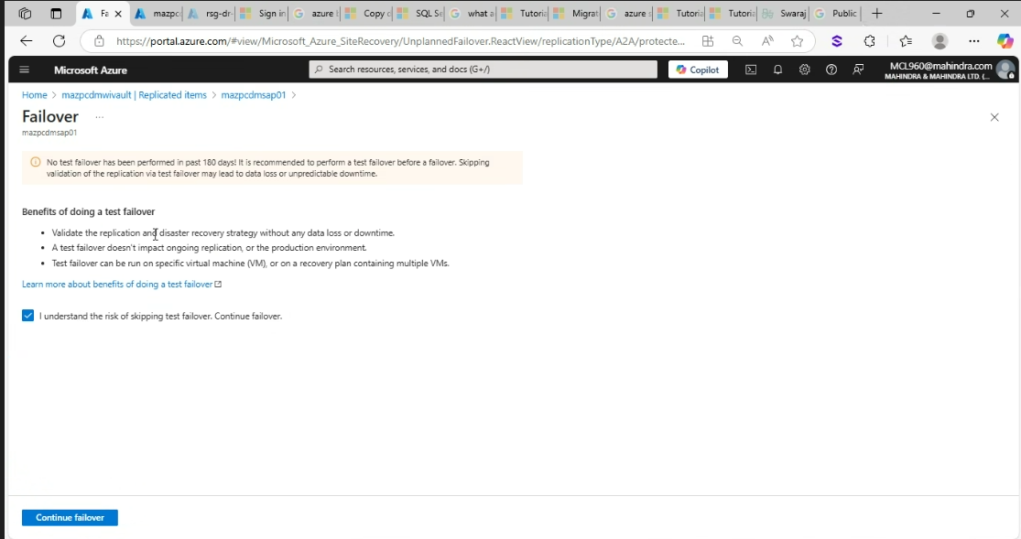

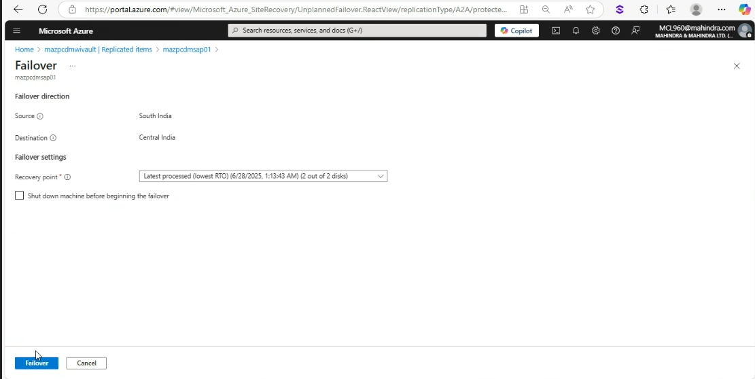
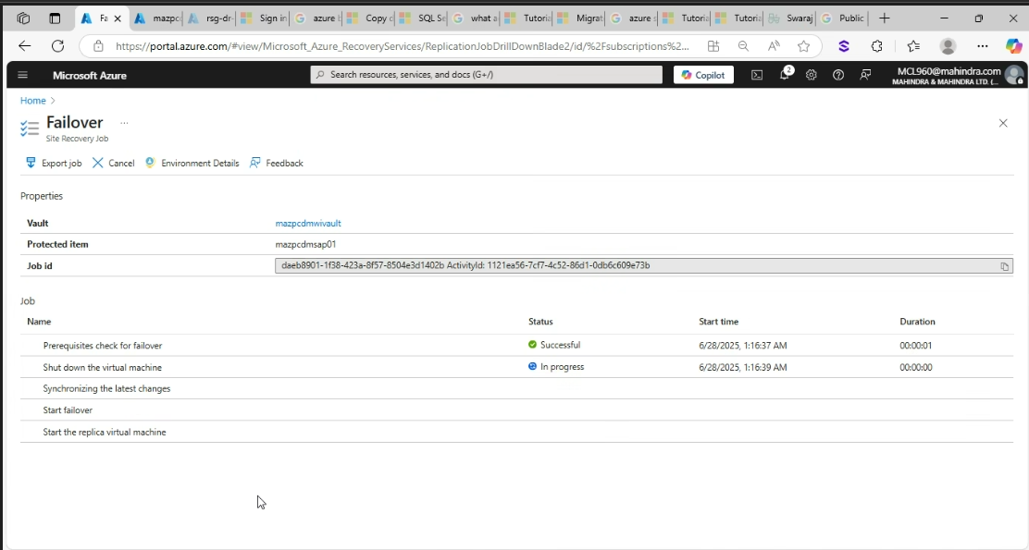

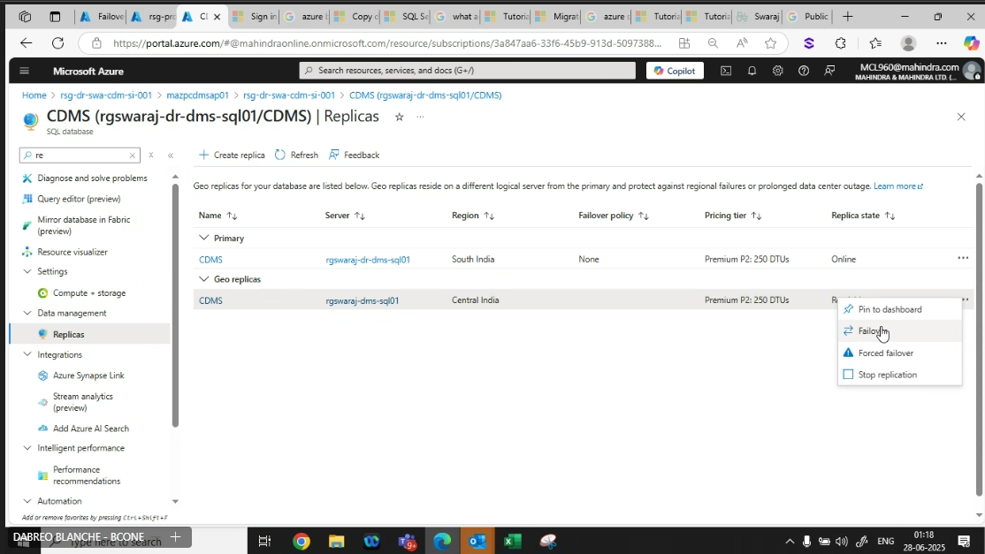
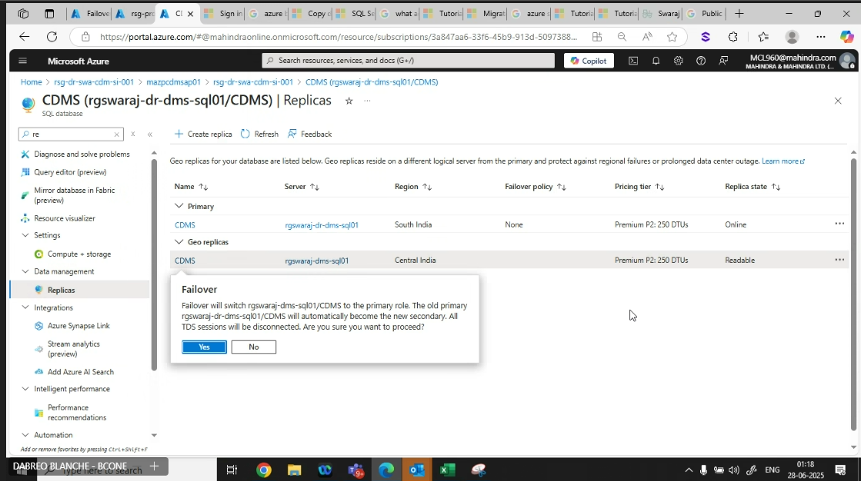

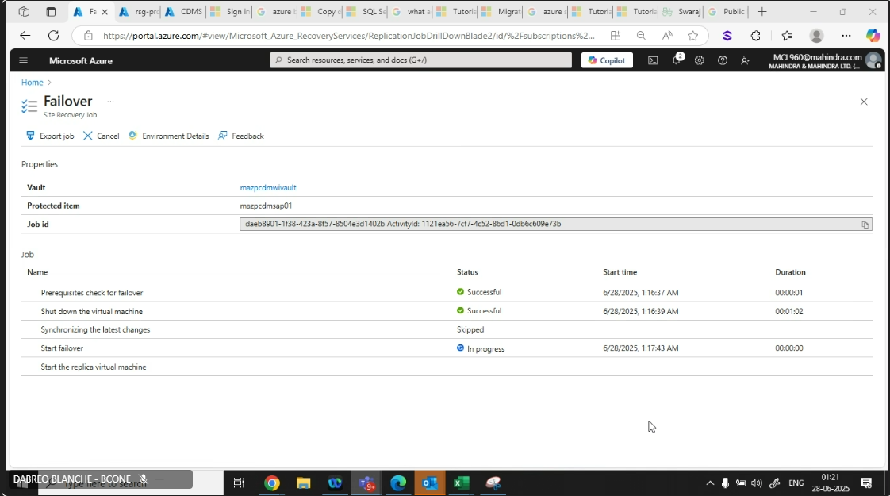
Adding VM to LB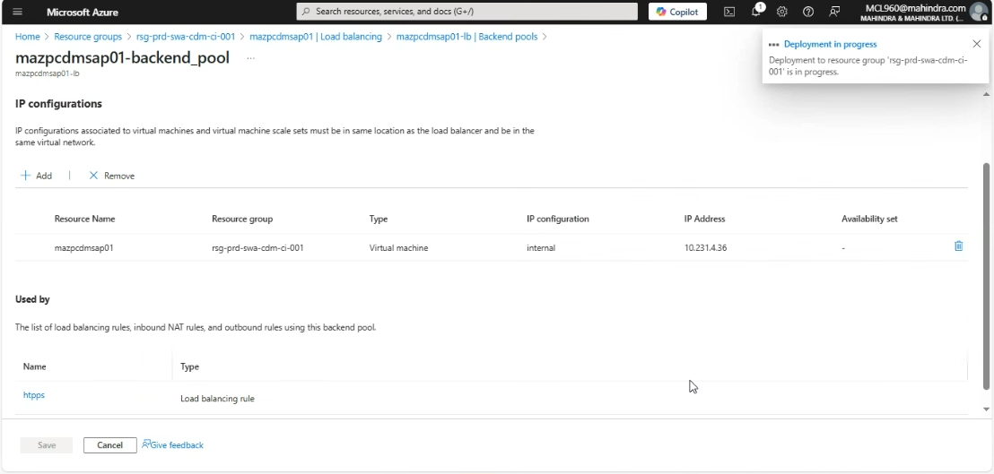
DNS Update to point to Prod VM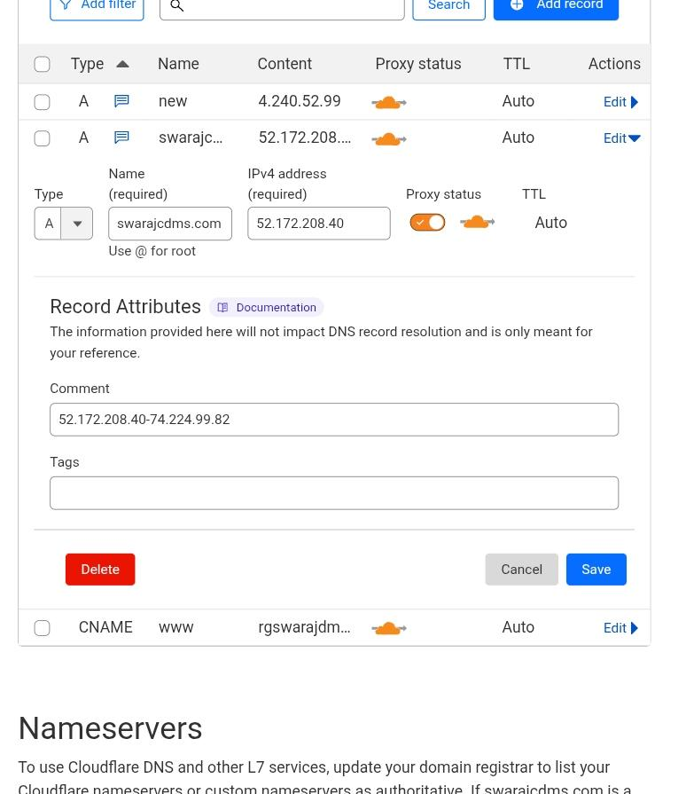

Re-protect Prod App VM